**DAILY ONLINE ACTIVITIES SUMMARY**

|  |  |  |  |  |  |  |  |  |
| --- | --- | --- | --- | --- | --- | --- | --- | --- |
| **Date:** | **25/06/2020** | | | | | **Name:** | **RITIKA R KULKARNI** | |
| **Sem& Sec** | **4​th​ SEM. & ‘B’ SEC.** | | | | | **USN:** | **4AL19CS403** | |
| **Online Test Summary** | | | | | | | | |
| **Subject** | | **- -** | | | | | | |
| **Max. Marks** | | **--** | | **Score** | | | **- -** | |
| **Certification Course Summary** | | | | | | | | |
| **Course** | **Introduction to Data Science** | | | | | | | |
| **Certificate Provider** | | | **Cognitive class** | | **Duration** | | | **5 Hrs.** |
| **Coding Challenges** | | | | | | | | |
| **Problem Statement:**   1. **Given a 2D array arr[][] of size M x N integers where M is the number of rows and N is the number of columns. The task is to reverse every row of the given 2D array.**   **Example:**  **Input: arr[][] =**  **{ {1, 2, 3},**  **{4, 5, 6},**  **{7, 8, 9} }**  **Output:**  **3 2 1**  **6 5 4**  **9 8 7** | | | | | | | | |
| **Status: Executed** | | | | | | | | |
| **Uploaded the report in Github** | | | | | **Yes** | | | |
| **If yes Repository name** | | | | | ------ | | | |
| **Uploaded the report in slack** | | | | | **Yes** | | | |

**Online Test Summary:**No internals conducted.

**Online Certification course Summary​:**I have taken my Online Certification Course in **Cognitive class** . Today I have gone throw **Recruiting for data science I attend test in cognitive class.**

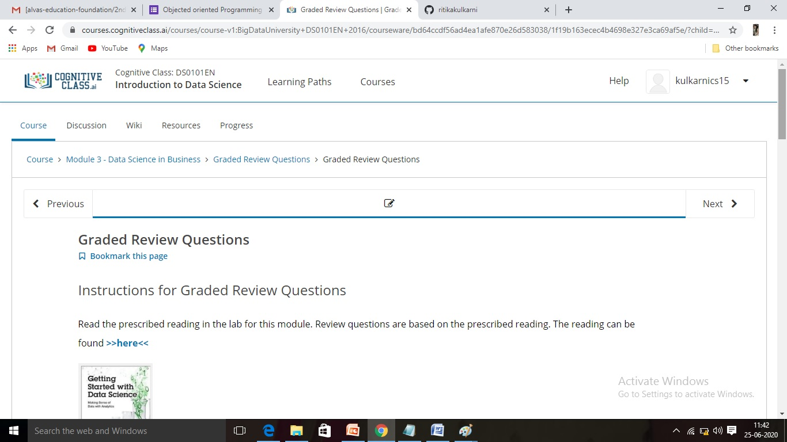

**Online Training**: Today I had attended the online training organized by CSE Dept AIET. The training was on C++ programming done by Prof. Shruthi Shetty CSE Dept. After the session the quiz was conducted. the snapshot that shown in below quiz attempted and the marks obtained.

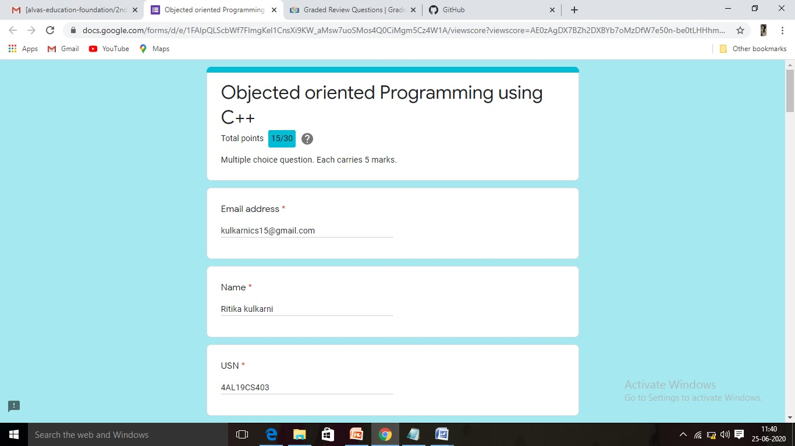

**Online Coding Summary​:Today I received three programs from Shilpa Mam and prof. Vasudev sir CSE Dept.. I have written two program and uploaded it to my Github repository. This is my repository snapshot. I have uploaded the frequency program.**

